February 20, 2026 Audit

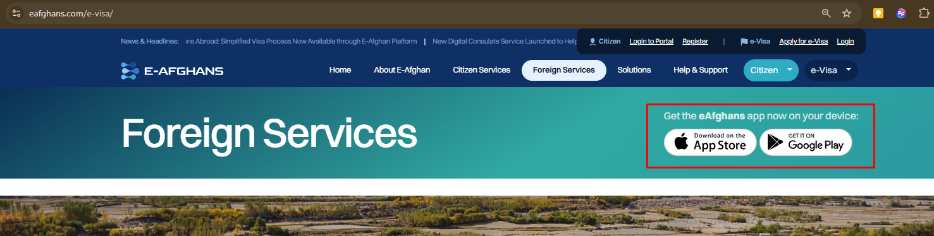
https://www.eafghans.com/e-visa/
Remove the download links for mobile, as there is no mobile app yet for visa services.
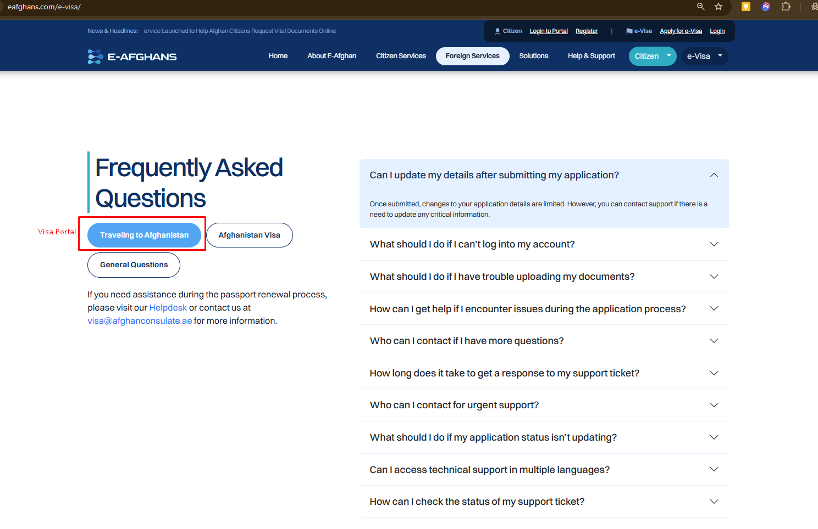

Change the Traveling to Afghanistan to Visa Application
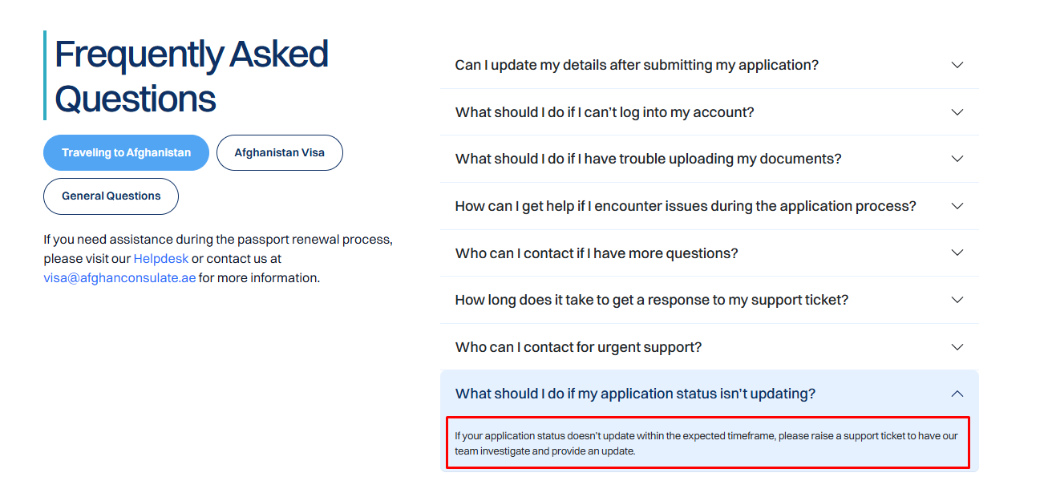
Change the text to:

E-Visa applications follow a standard processing time:
- Standard - 1-4 weeks
- Express - 1 Business Day

We request you to monitor the progress of your application via the Visa Portal. The Visa Portal dashboard reflects the real-time status of your application.

Processing may be delayed in the following circumstances:

- Submission of incorrect, incomplete, or expired documents
- Blurred, cropped, or unreadable passport copies or supporting documents
- Mismatch between application details and submitted documents
- Inconsistencies in personal information (e.g., name spelling, date of birth, passport number)
- Failure to meet visa eligibility requirements
- Missing mandatory information in the application form
- Pending or unsuccessful payment confirmation
- Requirement for additional verification or security checks
- Requests for supplementary documents or clarifications
- Technical issues affecting document uploads or data submission

If your application status doesn’t update within the expected timeframe, you may contact visa@afghanconsulate.ae

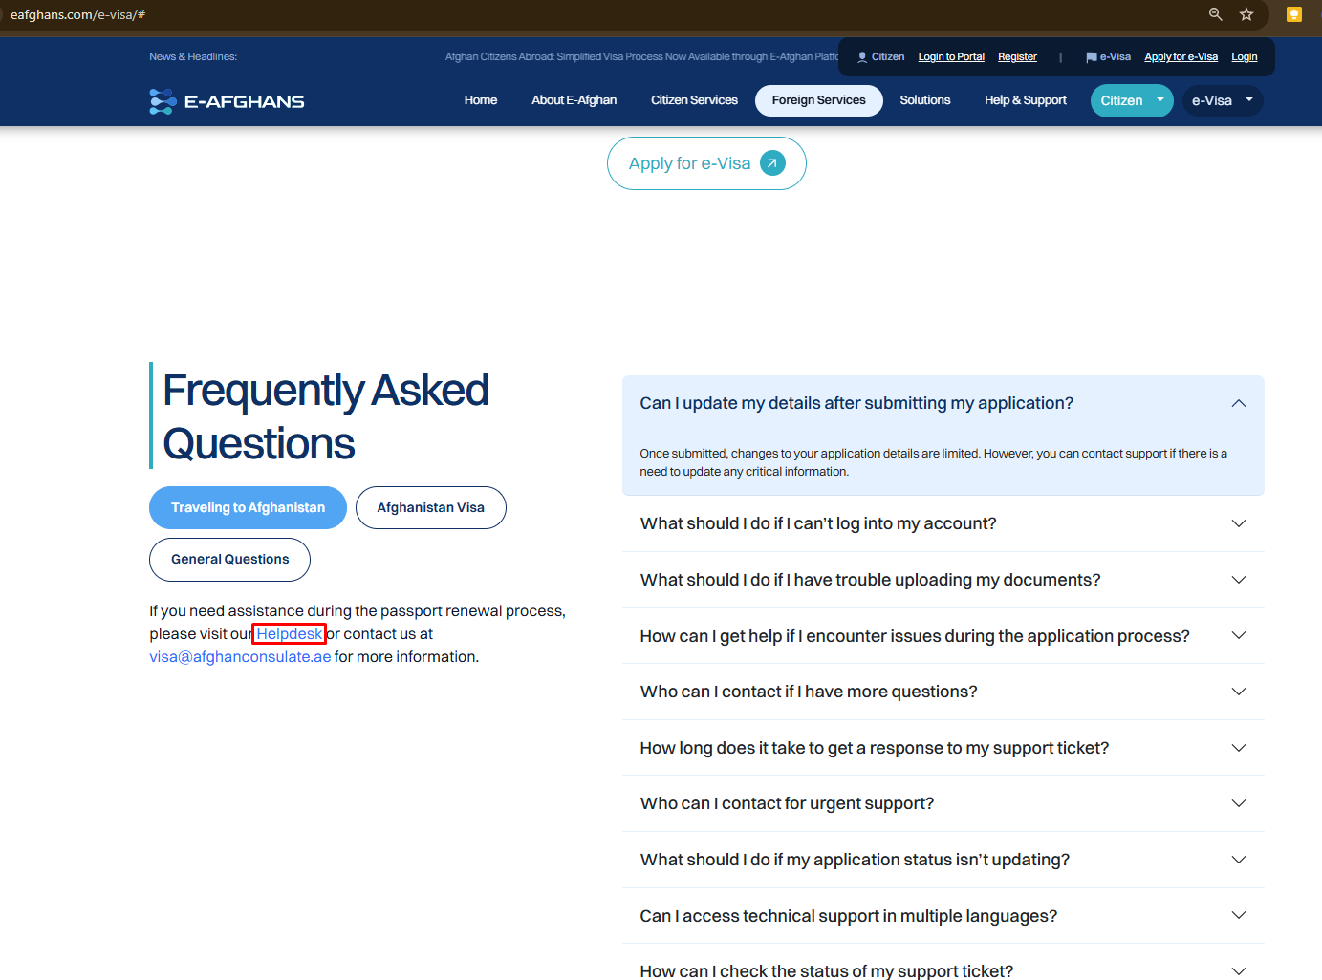
Redirect the Helpdesk link to https://www.eafghans.com/support/
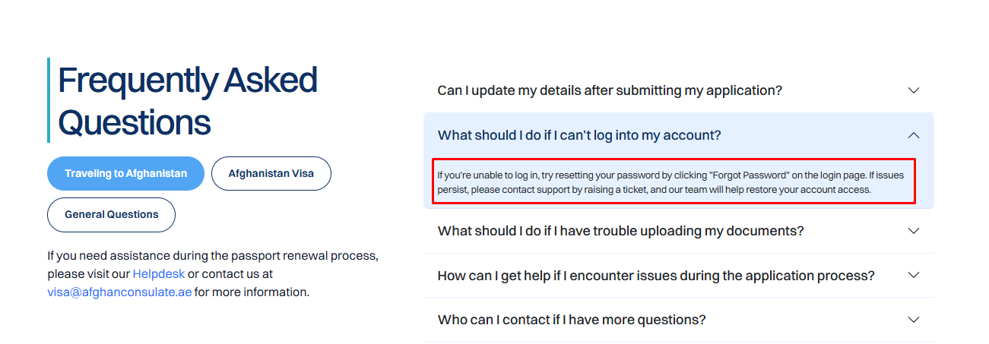
Change the content to:
If you are unable to log in to the Visa Portal, reset your password through this link: https://visaportal.eafghans.com/forgot-password

You will receive an email with the link to reset your password. Follow the instructions to reset your password. You will receive a confirmation email once your password has been reset successfully. After which, you may now log in.

Note: If you are not able to access the email via your inbox, check your Spam or Junk folder.
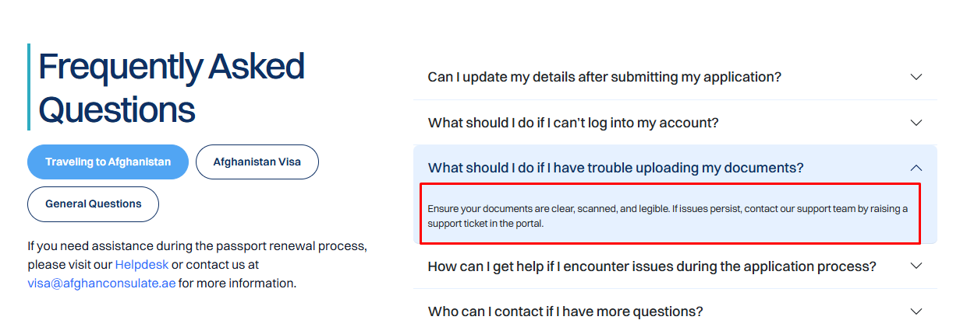
Change the content to:

Please ensure your uploads are in JPG, PNG, or PDF format. Other file types are not supported. Additionally, individual files must not exceed 50 MB.

Ensure your documents are clear, scanned, and legible. If issues persist, contact our technical support team via support@eafghans.com and send us the error you are facing.
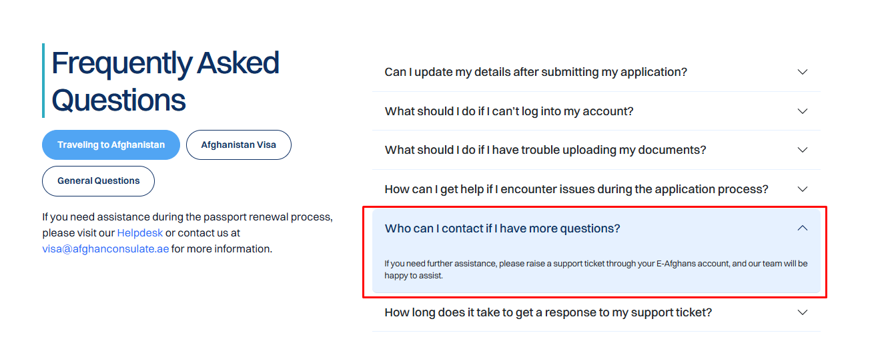
Remove
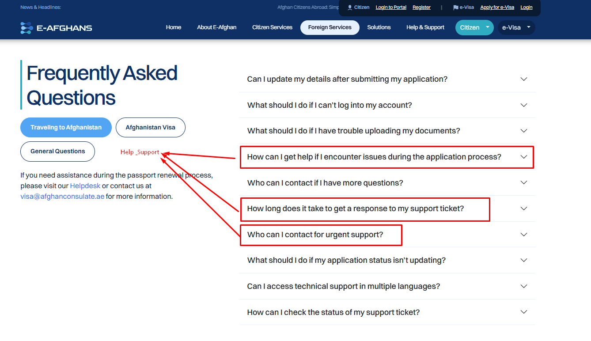

Move these 3 FAQs to a new category: Help & Support
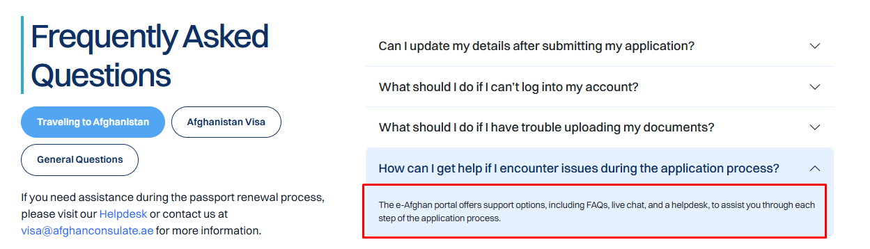
Change the content to:

For any inquiries regarding eligibility and requirements, refunds, updates, or changes related to your e-visa application, kindly reach out directly to visa@afghanconsulate.ae.

For any technical issues encountered while using the platform, contact support@eafghans.com.
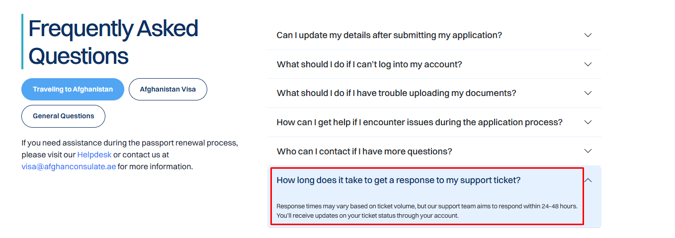
Change the content to:

How long does it take to get a response to my inquiry?

Response times may vary based on ticket volume, but our support team aims to respond within 2 business days.
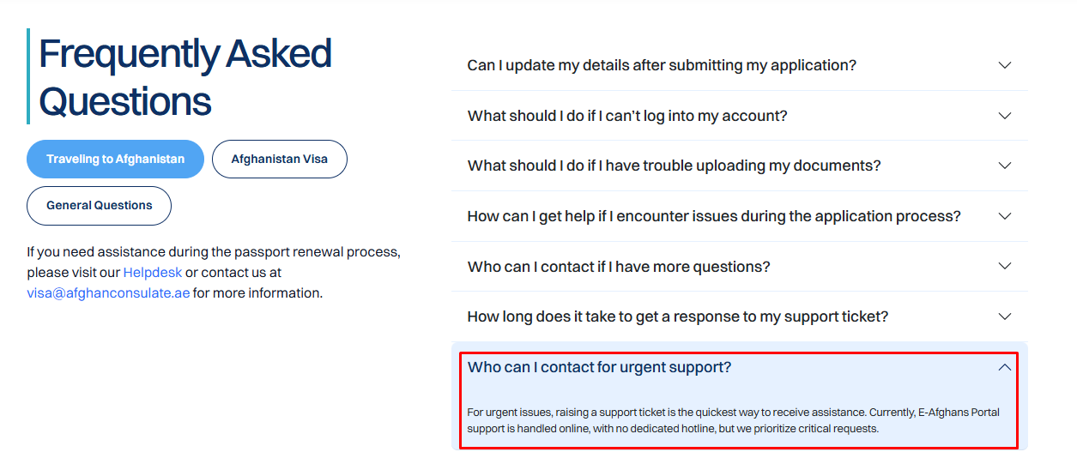
Change the text to:

Who can I contact for emergency support?

For emergency issues, please contact +971 4 398 8229.
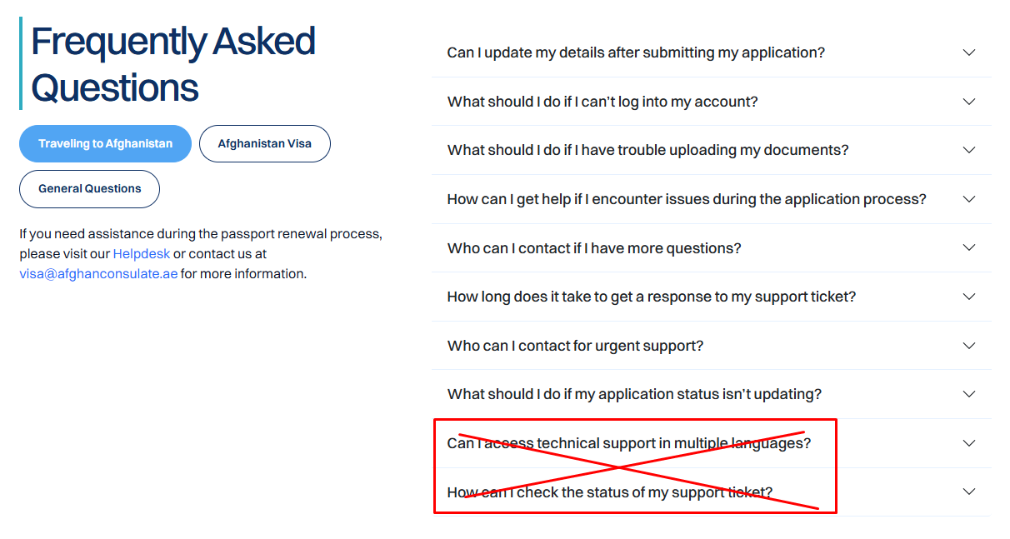
Remove
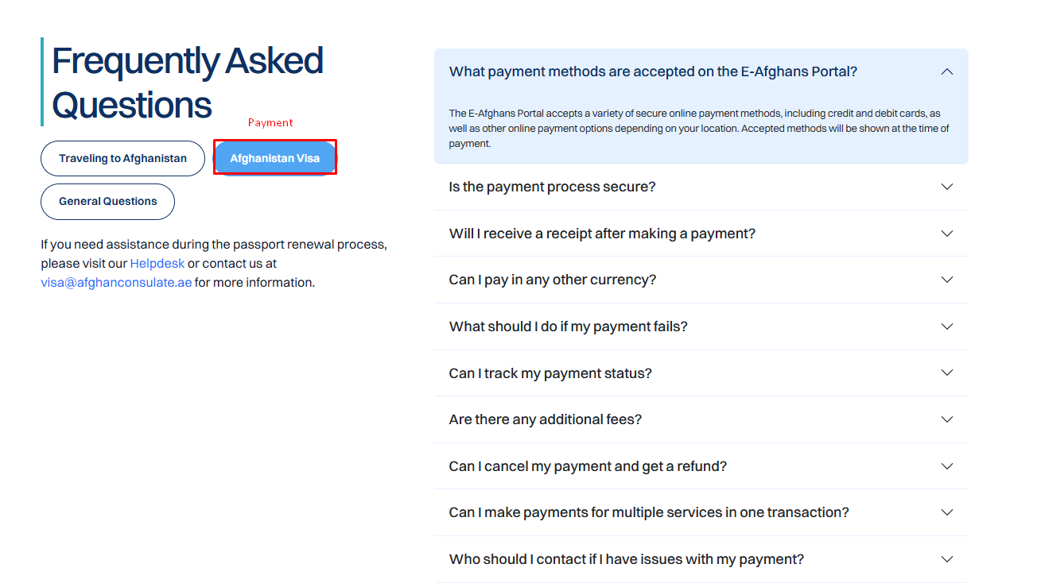
Change the category of Afghanistan Visa to Payment
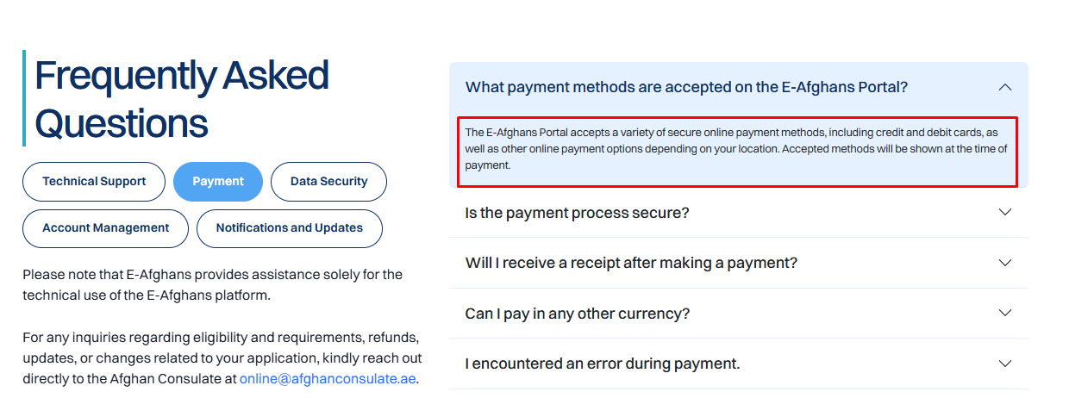
Change the text to:

The E-Afghans Portal accepts a variety of secure online payment methods, including credit and debit cards. Accepted methods are Visa / Mastercard / American Express.
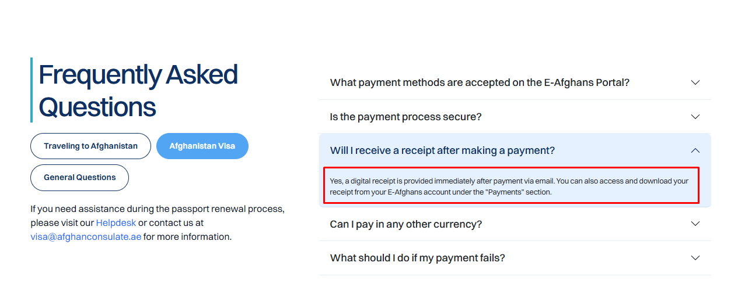
Change the text to:

Yes, a digital receipt is provided immediately after payment via email.
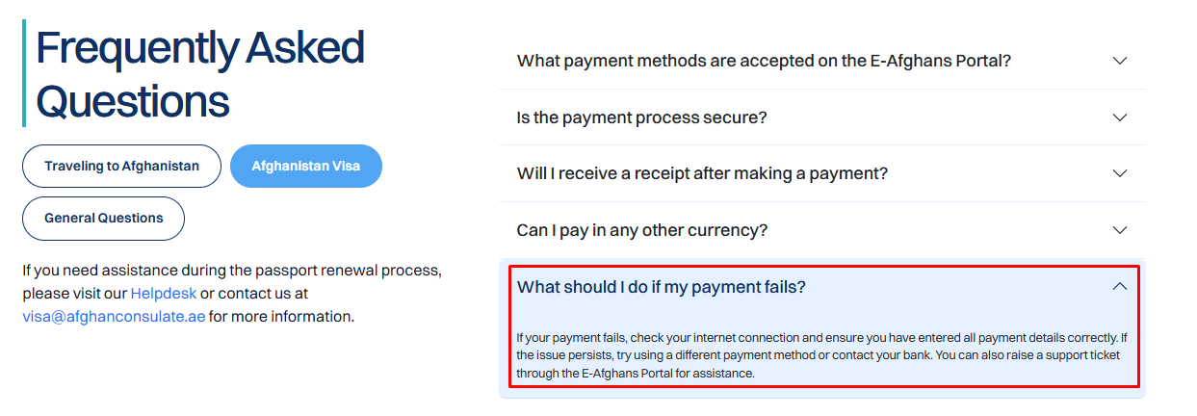
Change the text to:

If your payment fails, it may be due to one of the following reasons:

- Internet disconnection - Check your internet connection and ensure continued connectivity while making a payment.
- Incomplete details - Ensure that you have entered all payment details correctly.
- Unaccepted payment method - Currently, Visa / Mastercard / American Express are accepted. Try using a different payment method or contact your bank if the issue persists.
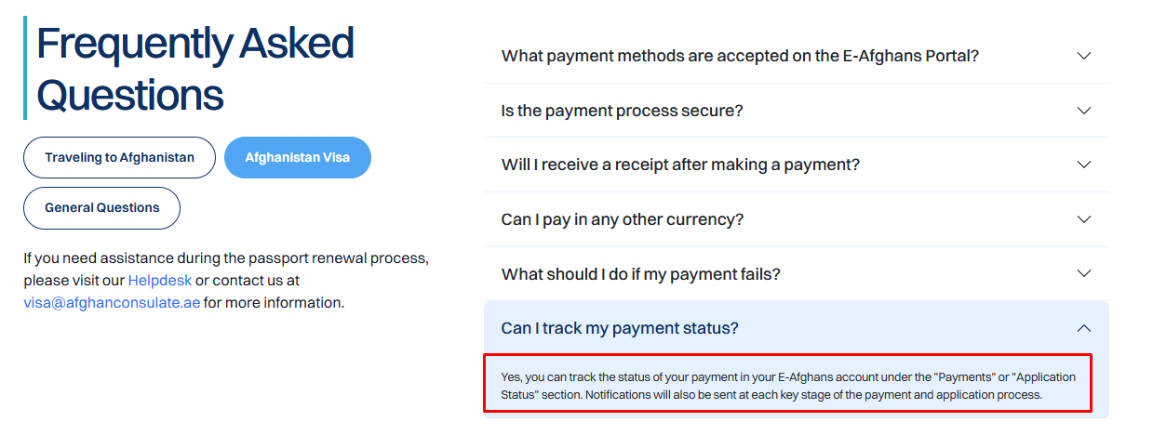
Change the text to:

Yes, you can track the status of your payment on your Visa Portal Dashboard.

Each application shows the status of the application and if Payment is still pending.
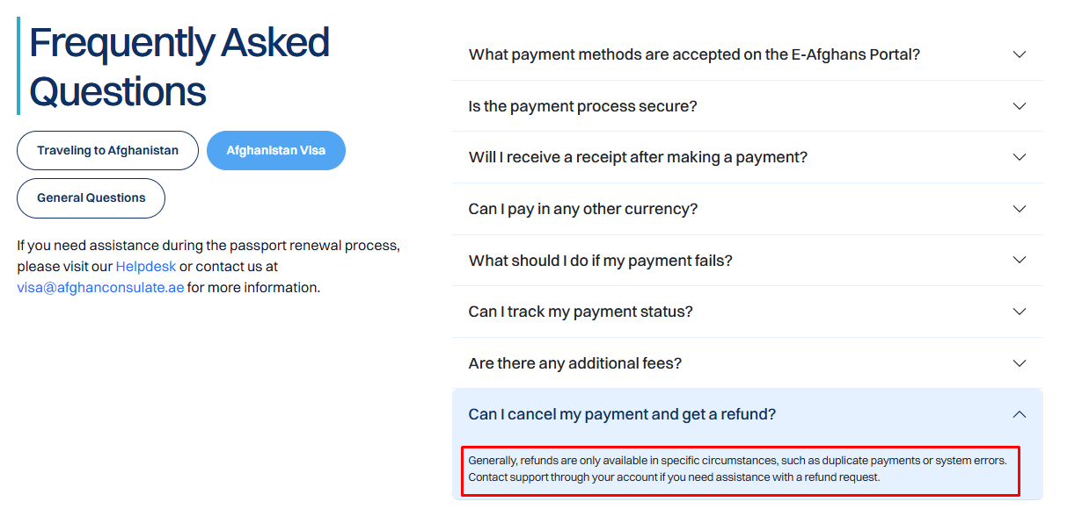
Change the text to:

All fees are non-refundable.

For more details about the refund policy, visit this page: https://www.eafghans.com/e-visa/visa-requirements.html
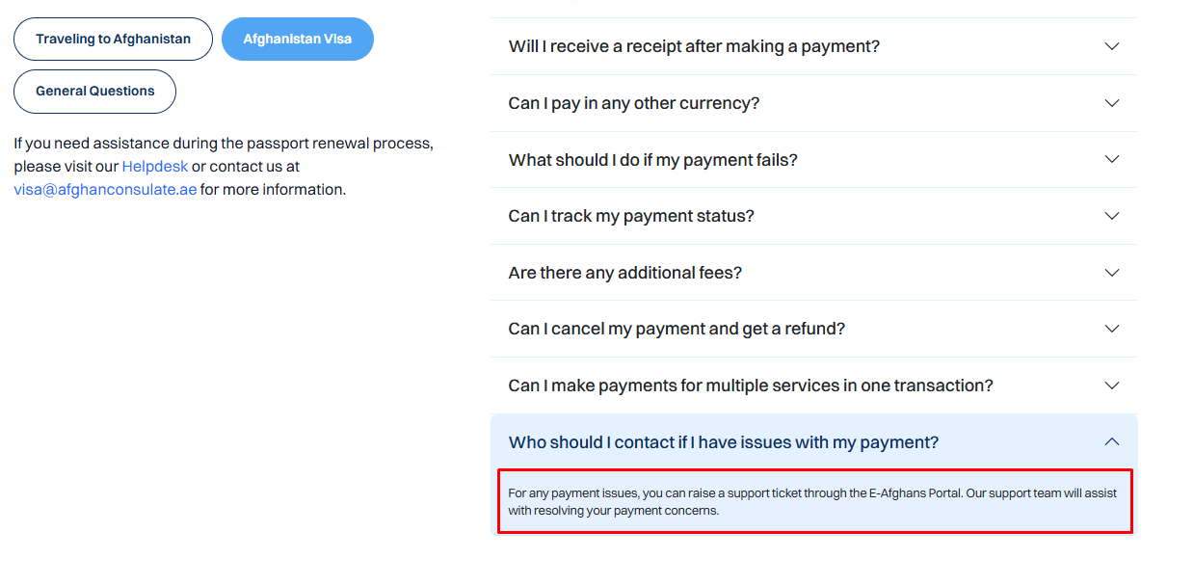
Change the text to:
If you think that the payment might have been erroneous or a duplicate, you may contact your bank to file a chargeback case.
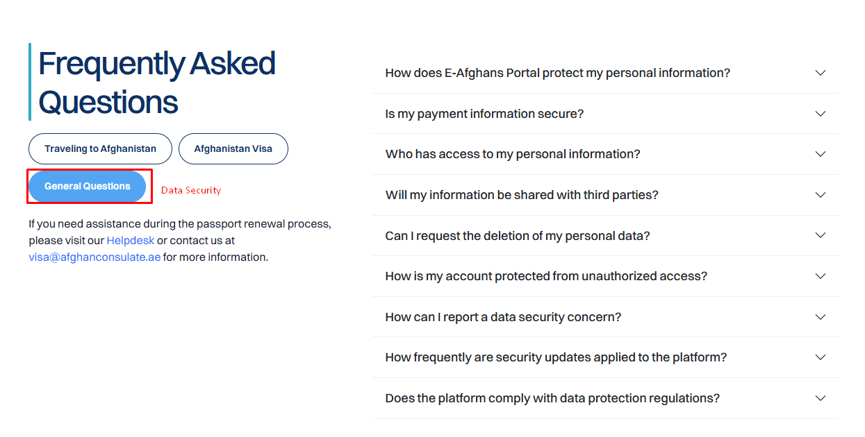
Change the category label to:

Data Security
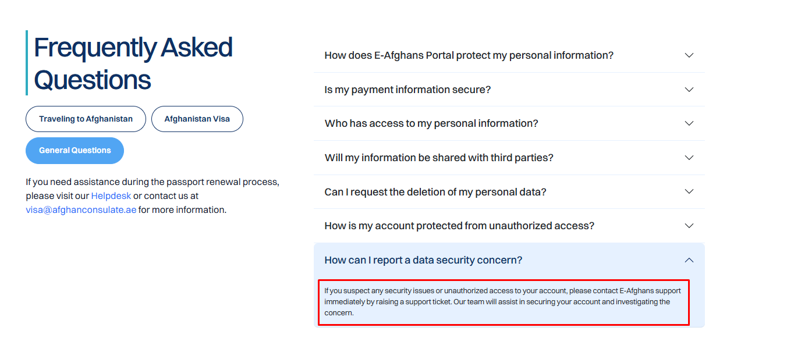
Change the text to:

If you suspect any security issues or unauthorized access to your account, please contact E-Afghans support at support@eafghans.com. Our team will assist in securing your account and investigating the concern.
Add a new FAQ to the Visa Application (should be the first question in this category):

How do I know if I am eligible to apply for an e-visa to Afghanistan?

Before proceeding with your application, ensure that you meet the eligibility requirements.

Find more information on this page https://www.eafghans.com/e-visa/visa-requirements.html about the e-Visa requirements before submitting an application.
Add a new FAQ to the Visa Application:

I need to travel to Afghanistan urgently. What should I do?

You may apply for an Express Visa if you need to travel urgently to Afghanistan.

The processing time for Express E-Visa applications is typically one (1) business day from the time a complete and accurate application is successfully submitted.

Please note that the one-business-day timeframe applies only to applications that are submitted with complete, clear, and correct documentation and do not require further review.

Find more information on this page https://www.eafghans.com/e-visa/visa-requirements.html about the e-Visa requirements before submitting an application.
Add a new FAQ to the Visa Application:

What e-visa type can I apply for?

Currently, we only issue a single-entry Tourist e-Visa valid for 30 days.

For other visa types, you may visit the Afghan Consulate or Embassy nearest you.
Add a new FAQ to the Visa Application:

Where can I download my e-visa?

You can download the e-visa from the Afghanistan Visa Portal.

The e-visa document will also be issued to you via your email.

Ensure that you have a working email to receive timely updates about your e-visa application.
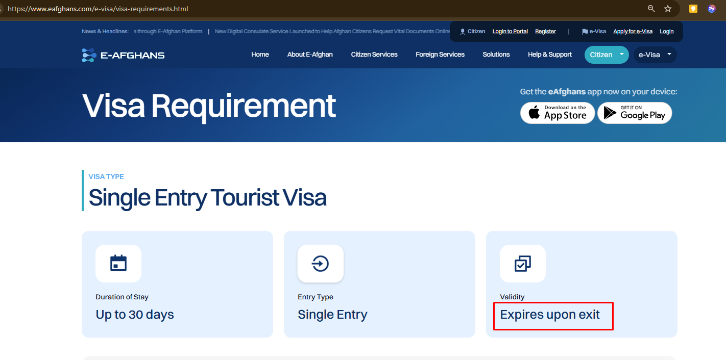
Change the text to:

Expires 30 days from the date of issue
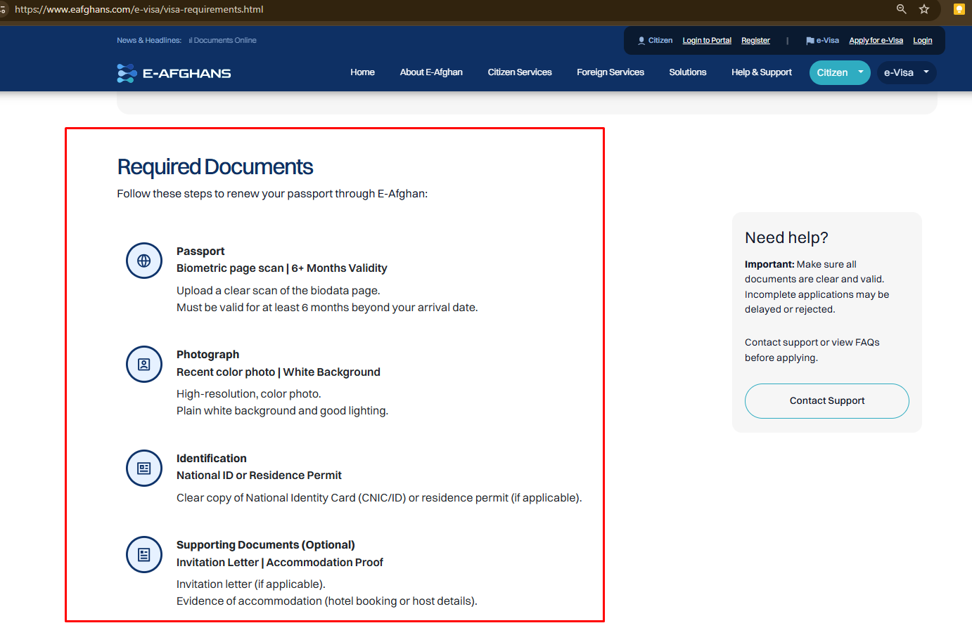
Changes needed in this section:

Required Documents: <h1>
Ensure that you possess the following documents in clear copy:

For applicants who are 18 years old and above: <h2>

- Electronic Passport
- Upload a clear scan of your passport biodata page.
- It must be valid for at least 6 months from the expiration date.
- For applicants less than 18 years old, a clear copy of parent’s passport is required.

- Colored Photograph
- Printed in color with WHITE BACKGROUND;
- With a size of 45 mm x 35 mm

- Other Identification Documents
- Clear copy of National Identity Card or residence permit (if applicable).

- Supporting Documents (Optional)
- Invitation Letter
- Itinerary
- Accommodation proof

DO NOT ADD BELOW INFO IN VISA REQUIREMENTS PAGE
How to Apply?

Follow the steps below to begin your e-visa application:

- Register an account on the E-Afghans Visa Portal
- Log in to your account
- Fill out the application form
- Submit the required documents
- Pay the initial fee to proceed with the processing
- Once your e-visa application has been approved, pay the remainder fee
- Upon successful payment of fees, your e-visa will be issued.
- Download your e-visa from the Visa Portal dashboard or from the email attachment.

E-Visa Processing Time: <h1>

Applicants can choose between two processing types: Standard or Express

- Standard Processing: Takes 1–4 weeks
- VIP Processing: Takes up to 1 business day

Please note that the timeframe stated above applies only to applications that are submitted with complete, clear, and correct documentation and do not require further review.

Processing may be delayed in the following circumstances:

- Submission of incorrect, incomplete, or expired documents
- Blurred, cropped, or unreadable passport copies or supporting documents
- Mismatch between application details and submitted documents
- Inconsistencies in personal information (e.g., name spelling, date of birth, passport number)
- Failure to meet visa eligibility requirements
- Missing mandatory information in the application form
- Pending or unsuccessful payment confirmation
- Requirement for additional verification or security checks
- Requests for supplementary documents or clarifications
- Technical issues affecting document uploads or data submission
- High application volume or peak travel seasons
- Public holidays or official closures affecting processing timelines

In such cases, the processing timeline will commence only after all required corrections or additional documents have been properly submitted.

Delays resulting from incomplete submissions, document discrepancies, or verification requirements are beyond the control of the Consulate and therefore cannot be attributed to consular processing.

E-Visa Fees: <h1>

Initial Fee: <h2>

- A payment link for the Initial Fee will be sent to you via email. You can also pay the Initial Fee via the E-Afghans VisaPortal.
- This must be paid at the time of application submission
- Required to begin processing and reviewing the application
- You have 48 hours to pay the Initial Fee—failure to pay it will automatically cancel and close your application, and you will have to reapply.
- The initial fee is non-refundable

Initial Fee | Online Service Fee | Payment Processing Fee | Total
Standard | USD 8 | USD 0.25 | USD 8.25
Express | USD 8 | USD 0.25 | USD 8.25

Remainder Fee: <h2>

- Upon the approval of your application, you will receive a payment link via email. You can also pay the Remainder Fee via the E-Afghans Visa Portal.
- This must be paid once the application is approved.
- Required to proceed with the e-visa issuance.
- You have 7 days to pay the Remainder Fee—failure to pay it will automatically cancel and close your application, and you will have to reapply.

Below is the detailed breakdown of fees for the online passport application.

Remainder Fee | Country | e-Visa Fee  (Tourist - 30 days) | Payment Processing fee | Total
Standard | USA | USD 200 | USD 6.19 | USD 206.19
Standard | Others | USD 120 | USD 3.71 | USD 123.71

Remainder Fee | Country | e-Visa Fee  (Tourist - 30 days) | Express fee | Payment Processing Fee | Total
Express | USA | USD 200 | USD 50 | USD 7.73 | USD 257.73
Express | Others | USD 120 | USD 50 | USD 5.26 | USD 175.26

Refund Policy: <h1>

Initial Fees <h2>

- The initial fee is non-refundable.
- This fee covers the administrative and processing costs required to initiate the application.

Remainder Fees <h2>

- The remainder fee is non-refundable.
- Once the e-visa has been issued, no refunds can be requested..

Duplicate Payments <h2>

- If a payment is made in duplicate, applicants may submit a dispute for review.
- Refunds for duplicate payments will be processed after verification by the consulate or relevant payment processor.

General Notes: <h2>

- All refund requests are subject to verification and approval by the Afghan Consulate.
- Refunds cannot be claimed for delays or issues related to applicant-provided incorrect information.

Cancellation Policy: <h1>

- Applicants may request cancellation before the application is processed.
- Initial fees are non-refundable and will not be returned upon cancellation.
- Once the application has been approved and the e-visa has been issued, the remainder fee cannot be refunded, even if the applicant cancels.
- If an application is submitted multiple times by mistake, applicants may contact the Consulate to review duplicate payments. Any eligible refund will be processed after verification.
- Important: The Afghan Consulate is not responsible for delays or costs arising from applicant errors following cancellation.

Acceptance of Terms <h1>

By submitting an online e-visa application and paying the initial fees, the applicant implicitly agrees to all the terms, policies, and conditions outlined on this page, including but not limited to:

- Application requirements and responsibilities
- Processing times and applicant obligations
- Refund and cancellation policies
- Fees, payment structure, and delivery procedures

Applicants acknowledge that: <h1>

- They have read, understood, and accepted all instructions and conditions.
- Any incomplete or inaccurate information provided may result in delays or rejection of the application, which is not the responsibility of the Afghan Consulate.
- All payments made (initial or remainder) constitute acceptance of the associated policies.
- Proceeding with the application constitutes a legally binding agreement between the applicant and the Afghan Consulate regarding the e-visa application process.
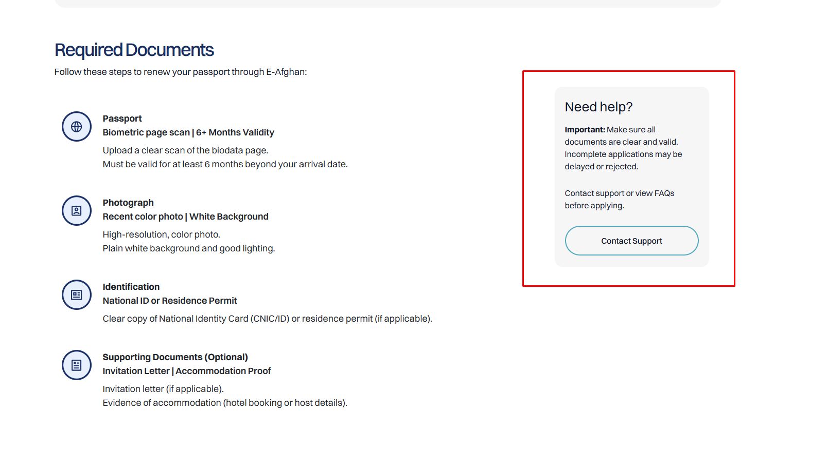

Change the content and CTA button

Avoid Rejection. Ensure you follow these guidelines!

- Make sure all the details you provided on the information are correct and accurate.
- Upload documents that are clear and valid. Incomplete applications may be delayed or rejected.
- Read the FAQs below for more information.
- Download our guide on e-Visa application by clicking the button below.

<CTA: Download Guide>

Guide link: https://drive.google.com/file/d/1lbVzYgNyzae8xnaEgTX__7f49L01js7s/view?usp=sharing

